Checking PC connections for Signal Light (Siglite).

- Can test if working by going to Drynet/Admin Tools/Siglite
If this test works than the PC is sending the signal.
- If not, check what port the cable is connected to. Go to Control Panel/System/Ports and see what port is available either a USB to serial (Prolific port usually COM5 or 7) or Serial on Board (usually COM9).
- Make sure the siglite is looking for this port. Go to Regedit:
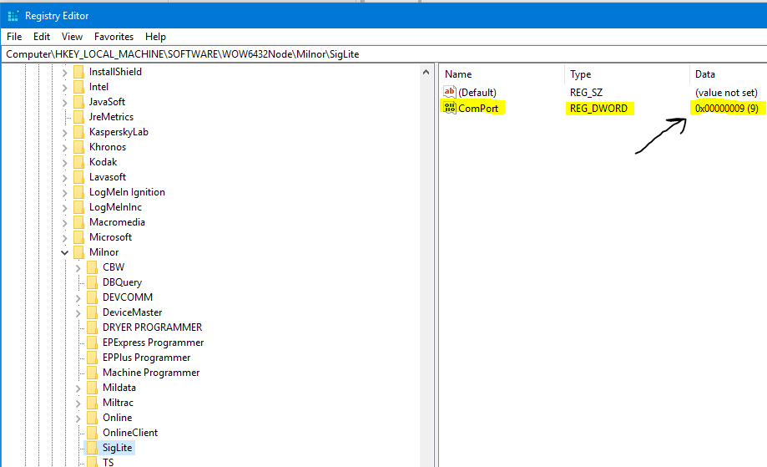

Make sure ComPort matches what is shown in control panel. Reboot if any change has been made.

